JSMJSM

**Non-Invasive point of care ECG signal detection and analytics for cardiac diseases**

**Bachelor of Technology**

*for the course*

**CL 498 Project II**

*by*

**Shubham Kumar Gupta**

**Roll No. 180107058**

*under the supervision of*

**Assistant Professor Resmi Suresh**

**Professor Dipankar Bandyopadhyay​**

*to the*

### DEPARTMENT OF CHEMICAL ENGINEERING

### INDIAN INSTITUTE OF TECHNOLOGY GUWAHATI GUWAHATI-781039, INDIA *Jan-May 2021*

  
**INDIAN INSTITUTE OF TECHNOLOGY, GUWAHATI**

**Department of Chemical Engineering**

Guwahati – 781039 (Assam)

**CERTIFICATE**

*It is certified that the project work entitled "Non-Invasive point of care ECG signal detection and analytics for cardiac diseases" that is being submitted by* ***Mr. Shubham Kumar Gupta (Roll no. 180107058),*** *is a bonafide work carried out under my supervision in the Department of Chemical Engineering, I.I.T. Guwahati and this work has not been submitted to any other institution or university for any degree.*

**Date:**

**Dr. Resmi Suresh**

Assistant Professor

Department of Chemical Engineering

Indian Institute of Technology

Guwahati-781039, Assam, India

# **ACKNOWLEDGEMENT**

This undertaking would not have been feasible without the assistance of numerous individuals, all of whom are truly appreciated and heartily acknowledged for their contributions. I would like to take this opportunity to express my gratitude and indebtedness to **Assistant Prof. Reshmi Suresh** and **Prof. Prof. Dipankar Bandyopadhyay**, my project supervisor, for their enthusiasm, patience, insightful comments, useful information, practical advice, and never-ending ideas throughout this project, as well as for instilling in me a sense of research aptitude. I would want to convey my heartfelt appreciation to him for his unflinching support and assistance.

**Shubham Kumar Gupta**

Roll No. 180107058

Dept. of Chemical Eng.

I.I.T. Guwahati

**Table of Contents**

|  |  |  |
| --- | --- | --- |
| S No. | Title | Pg. No |
| X | **Abstract** | 5 |
| XX | **Nomenclature** | 6 |
| 1 | **Introduction** | 7 |
| 2 | **Theoretical Background** | 9 |
| 2.1 | Heart’s Medical Background |  |
| 2.2 | Overview of an Abnormal Heart |  |
| 2.3 | Conduction Systems of the Heart |  |
| 2.4 | Electrical Pathway of the Heart |  |
| 2.5 | Electrocardiogram (ECG) |  |
| 2.5.1 | Morphology of the intervals of Normal ECG |  |
| 3 | **Literature Review** | 15 |
| 3.1 | Steps to Perform ECG |  |
| 3.2 | Working Principle of ECG |  |
| 3.3 | Case Studies |  |
| 3.3.1 | Apple’s Single Lead ECG Watch |  |
| 3.3.2 | Sanket’s 12 Lead ECG |  |
| 3.4 | Electrode & Micro-Pattern Electrodes |  |
| 3.5 | Sample Dataset |  |
| 4 | **Methodology** | 22 |
| 4.1 | Objective |  |
| 4.2 | Block Diagram |  |
| 4.3 | Sources of Noise |  |
| 4.4 | Circuit Diagram & Components |  |
| 4.5 | Datapoints |  |
| 4.6 | Redefining Dataset |  |
| 4.7 | Dataset Modelling and Architecture |  |
| 5 | **Results and Discussions** | 24 |
| 6 | **Conclusions** | 28 |
| 7 | **References** | 29 |

# **ABSTRACT**

Cardiovascular disorders account for one in every three fatalities worldwide and are the major cause of death. India has one of the world's highest cases of cardiovascular diseases. In India, annual cardiovascular diseases deaths are expected to grow from 2.26 million in 1990 to 4.77 million in 2020. Coronary heart disease prevalence rates in India have been evaluated over several decades and have ranged from 1.6 to 7.4 percent in rural areas and from 1% to 13.2% in urban areas. Heart attacks and strokes are typically caused by the presence of a number of risk factors, including cigarette use, an unhealthy diet and obesity, physical inactivity and alcohol consumption, hypertension, diabetes, and a high cholesterol level. Electrocardiograms can be used to detect cardiovascular disorders (or ECG). This test is frequently used to diagnose heart disease, a heart attack, an enlarged heart, or irregular heart rhythms that may contribute to heart failure. While there are traditional methods and devices for performing ECG, the setup is expensive, time-intensive, and requires a high level of awareness of how to execute and evaluate ECG. As generations change, there is a need for a portable, cost-effective, and self-predicting cardiovascular disease technology that can detect heart risks with minimal setup and understanding. When it comes to the improvement of heart health, it is never too late to adopt new technologies. The study discusses the most prevalent cardiovascular anomalies, analyses ECG waves and non-invasive ECG measuring techniques, and intends to design a device that can measure ECG signals non-invasively. Numerous case studies of currently available items on the market were analyzed and used to deduce constraints and techniques. The biosensors used in the manufacture of devices have been explored. Additionally, the study on "Atrial Fibrillation" identification was conducted using a single lead ECG dataset (a database of ECG amplitudes v/s time for persons aged 30-80 years). Using ECG measurements, a Convolutional Neural Network model is utilized to predict "Atrial Fibrillation." The study discovered that Convolutional Neural Networks were capable of accurately predicting the same with a 81.36% accuracy.

# **NOMENCLATURE**

|  |  |  |
| --- | --- | --- |
| Symbol | Meaning | Units |
| ECG/EKG | Electrocardiogram |  |
| Op-Amp | Operational Amplifier |  |
| A.F. | Atrial Fibrillation |  |
| CVD | Cardio Vascular Disease |  |
| AV | Atrio Ventricular |  |
| A.D.C. | Analog To Digital Converter |  |
| CNN | Convolution Neural Network |  |
| ANN | Artificial Neural Network |  |
| G.P.S. | Global Positioning System |  |
| µ | Dipole Moment | Cm |
| Φ | Potential at a position | V |
| I | Current | A |
| V | Voltage | V |
| T | Temperature | K |
| R | Resistor | Ω |
| C | Capacitor | ㎌ |
| L | Inductor | H |
| B.P.M. | Beats Per Minute | beats/m |
| aVL | augmented Vector Left | V |
| aVR | augmented Vector Right | V |
| aVF | augmented Vector Foot | V |
| DC | Direct Current | A |
| AC | Alternating Current | A |

# **INTRODUCTION**

Ailments that impact the function of our hearts are referred to as heart disease. It could be caused by problems with the heart's blood supply, heart rate or rhythm, or defects in the cardiac artery's architecture. Heart disease kills about 17.5 million people each year, according to the World Health Organization (WHO) reports. It is essential to evaluate and recognize heart illness early to protect against sudden mortality as a result of heart attack or cardiac arrest. Cardiologists employ a sensor for the electrocardiogram (ECG) to quickly and without intervention detect abnormal heart rhythm and signs of likely heart disease.

The demand for value-added components has increased as smartphones and tablets have grown in popularity. The most common way to sell content for mobile devices has been to sell "apps" on online marketplaces. These are usually pure software add-ons that take advantage of the existing platform's hardware capabilities. These devices now come with high-resolution touch screens, accelerometers, G.P.S., and cellular and wireless data access as standard hardware. For general-purpose applications, these hardware interfaces provide a high-quality standard development environment. This set of hardware may not be sufficient for more specialized applications, but it does serve as an exemplary user interface, recording platform, and network uplink.

In today's environment, obtaining affordable healthcare is a challenge. As government organizations and private businesses look for ways to save money, there may be a market opportunity to utilize mobile device technology's widespread availability. In the future years, even emerging countries' capable low-end smartphone markets are likely to rise. Several physiological data sets could be helpful to the health business. One might, for example, have persistent symptoms that are difficult to replicate in a therapeutic environment.

Using the circulatory system, the heart removes carbon dioxide and wastes from the blood while providing oxygen and nutrition to the body's tissue. People who have a problem with their hearts can suffer from abnormal heartbeats that are either too rapid or too sluggish. Arrhythmia is the medical term for this condition. There are a number of values, nodes, and chambers in the heart that control blood flow. There are different types of abnormal heartbeat; they are Atrial Fibrillation and Flutter, Congestive Heart Failure (CHF), Congestive (Dilated) Cardiomyopathy, Mitral Value Prolapse, Hypertensive Heart Disease, Cardiogenic Shock, Dissection of the Aorta, Hypokalemia, Hyperthyroidism, Anaphylaxis, Hypoglycemia (low blood sugar), Hypothyroidism, Aortic Coarctation, Ventricular Septal Defects. The abnormal heartbeat has various types. When an individual's heart rhythm is aberrant, this is referred to as abnormal cardiac rhythm. It occurs when an individual's heart's electrical system malfunctions or fails to perform properly. This could be an indication of undiagnosed coronary heart disease or another medical condition. Arrhythmias are caused by irritable cardiac cells, blocked signals, aberrant routes, medications and stimulants, and spasms of the coronary arteries. Electrocardiography is used to diagnose arrhythmias (ECG). The ECG demonstrates to the physician how the heart's electrical circuitry operates.

The most common cause of irregular cardiac rhythm is heart disease. While individuals are occasionally aware of irregular cardiac rhythms, they frequently experience only their repercussions, such as weakness or fainting. Electrocardiography is used to determine the cause of the patient's heart condition. Treating an irregular heartbeat and preventing future episodes is the purpose of this therapy. In order to control the contraction of the cardiac muscle fibers, electrical current is carefully routed through the heart in a controlled manner. Each heartbeat is initiated by an electrical current generated by the heart's pacemaker (also known as the sinus node or sinoatrial node), which is located at the top of the upper right heart chamber (right atrium). The heart rate is determined by the rate at which the pacemaker discharges the electrical current. This pace is determined by nerve impulses and the blood level of specific hormones.

Convolution Neural Networks have been used to construct a predictive model for "Atrial Fibrillation" based on ECG data points from the "Physionet AliveCor's Short Single Lead ECG Recording" dataset. Normal and abnormal ECGs were included in the data collection, which had amplitude and time values for each ECG In ECG datasets, a single row appears to be an image matrix. The Convolution Neural Network model was suggested as a possible solution to the problem of image classification. When an image is fed into a Convolutional Neural Network (CNN), the algorithm assigns weights and biases (learnable) to various parts of the image and is able to distinguish between them. As opposed to other classification techniques, ConvNets require less pre-processing. While in basic approaches, filters are hand-engineered, ConvNets have the potential to learn these filters/characteristics with sufficient training. The architecture of ConvNet is similar to that of human brain connectivity patterns and was inspired by visual cortex arrangement. The Receptive Field is the area of the visual field in which individual neurons respond to stimuli. The entire visual field is covered by a collection of these fields.

**2. THEORETICAL BACKGROUND**

**2.1 Heart's Medical Background**

As illustrated in figure 1, The heart is placed in the center of our chest, between lungs, slightly to the left of our breastbone, in the middle of our chest (sternum). The pericardium is a double-layered membrane that surrounds and protects your heart, similar to a sac. The anterior pericardium is the outer layer of our heart's major blood vessels that covers the roots of our heart's major blood arteries and is related to the spinal column, diaphragm, and other areas of our body through ligaments. The heart and blood arteries make up the cardiovascular system. The heart serves as a pump, delivering blood to all of the organs, tissues, and cells in your body. Veins return blood to the heart. The heart has a total of four chambers, two upper (the atria) and two lower (the ventricles). The heartbeat is the muscular contraction of the heart muscle that occurs during the process of blood pumping.

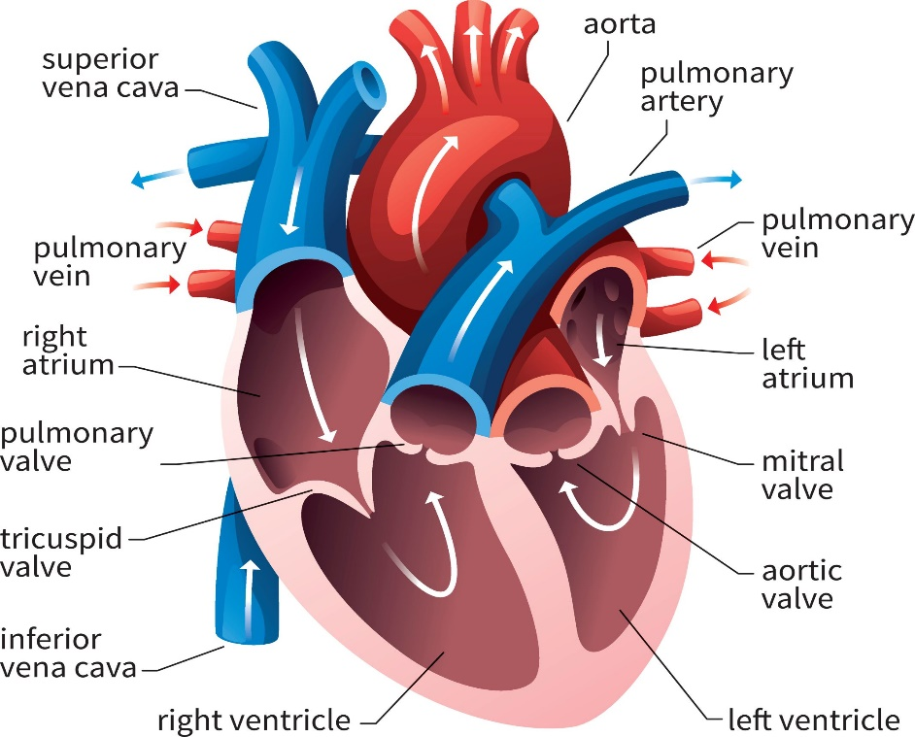

**Fig 1. Heart's Anatomy, Source: cardofmich.com**

**2.2 Overview of an Abnormal Heart**

There is a total of four chambers in our heart, each having a specific role. Muscular walls in each chamber of the heart contract in a coordinated sequence, pumping blood as the body needs while expelling the least amount of energy feasible throughout each heartbeat. The most common cause of irregular cardiac rhythm is heart disease. While people are occasionally aware of irregular cardiac rhythms, they frequently only feel their repercussions, such as weakness or fainting. When an individual's heart rhythm is aberrant, this is referred to as abnormal cardiac rhythm. It occurs when an individual's heart's electrical system malfunctions or fails to perform properly. This could be an indication of undiagnosed coronary heart disease or another medical condition. Arrhythmias are caused by irritable cardiac cells, blocked signals, aberrant routes, medications and stimulants, and spasms of the coronary arteries. It is only when the heart rate is excessively rapid (referred as tachycardia) or sluggish (referred to as bradycardia) that the cardiac rhythm is considered abnormal. Figure 2 denotes Atrial Fibrillation; figure 3 denotes tachycardia; figure 4 denotes Bradycardia.

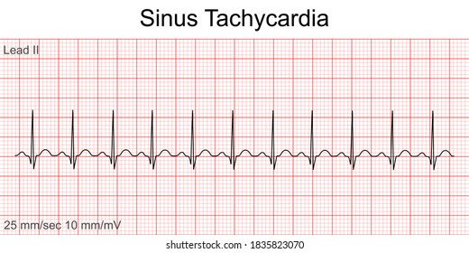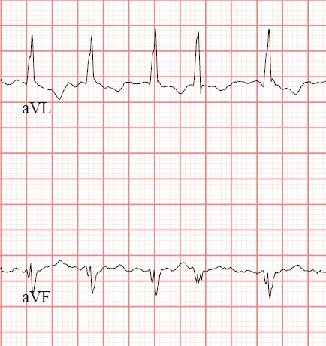 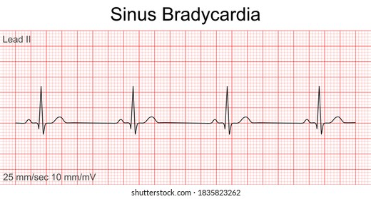

**Fig 2 Atrial Fibrillation Fig 3 Tachycardia Fig 4 Bradycardia**

**Source: stemlynsblog.org**

**2.3 Conduction Systems of the Heart**

Contraction of the cardiac muscle fibers is regulated by electricity that passes precisely through the heart along different channels at a controlled rate. Each heartbeat is initiated by an electrical current generated by the heart's pacemaker (also known as the sinoatrial node), which is located at the top of the upper right heart chamber (right atrium). The heart rate is determined by the rate at which the pacemaker discharges the electrical current. This pace is determined by nerve impulses and the blood level of specific hormones. The sympathetic and parasympathetic sub-divisions of the autonomic nervous system control the heart rate. The sympathetic division raises the heart rate via a network of nerves known as the sympathetic plexus. Through a single nerve, the vagus nerve, the parasympathetic division slows the heart rate. Heart rate is also controlled by sympathetic hormones named epinephrine (adrenaline) and norepinephrine that are released into the bloodstream by the sympathetic division (noradrenaline). This sympathetic division causes the heart rate to increase. When thyroid hormone is released into the bloodstream by the thyroid gland, it also increases heart rate. At rest, an adult's heart rate should be between 60 and 100 beats per minute. Lower rates may be expected in adolescents and young adults, particularly those who are physically fit. The heart rate of an individual generally varies in reaction to exercise and other stimuli such as pain and anger. Figure 5, show the conduction system of our heart.

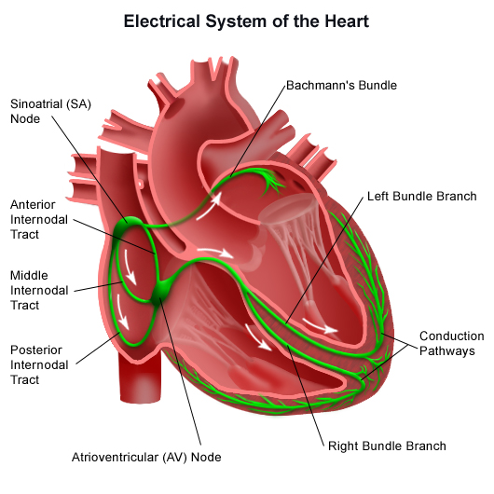**.**

**Fig 5. Conduction System of the Heart, Source: researchgate.net**

**2.4 Electrical Pathway of the Heart**

The sinoatrial (sinus) node is responsible for generating an electrical impulse that travels across the right and left atria, causing them to constrict and contract. When an electrical impulse reaches the atrioventricular node, it is slightly delayed in its arrival time. It descends the His bundle, which is separated into two branches: the right bundle branch, which leads to the right ventricle, and the left bundle branch, which leads to the left ventricle. It subsequently spreads to the ventricles, constricting them.Electrical current travels along with the bundle of His after it has passed through the atrioventricular node. Right, and left ventricular bundles are formed by a bundle of His, which is a cluster of fibrous tissue. Starting at the bottom, it travels throughout the ventricle's surface, squeezing them and causing blood to be evacuated from the body. Figure 6 shows the electrical pathway of our heart.

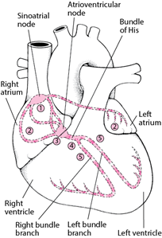

**Fig 6. Electrical Pathway of Heart, Source: Sciencedirect.com**

**2.5 Electrocardiogram (ECG)**

The heart's electrical signals are shown graphically in this diagram. In 1983, Willem Einthoven was the first person to utilize an electrocardiogram (ECG). The ECG is made up of three main signal components. Certain diseases may cause an abnormal heartbeat, which may indicate the presence of an arrhythmia by altering one of these traces. Using electrodes, the ECG records the heart's electrical activity by putting electrodes (up to 12 electrodes) at various points on the body. It's well accepted that the automation of cardiac arrhythmias using ECG is an essential area of study in today's medical community. Electrocardiography (ECG) and Tilt Tests are used to diagnose arrhythmias. The ECG demonstrates to the physician how the heart's electrical circuitry operates. Tilt tests inform the physician whether or not various body positions will cause an arrhythmia. They are effective for examining the hearts of individuals who have unexplained fainting. Electrocardiography is used to make the diagnosis. The treatment goal is to restore the heart's normal rhythm and prevent future episodes. It is drawn on a special form of graph paper in which 1mm corresponds to 0.04s on the x-axis and 0.1mV on the y-axis. On the right side of the graph paper is a square wave pulse symbol representing the calibration level, where a peak equals two square boxes, i.e., a 1mV signal represents a 10mm deflection. An ECG recording contains a total of 12 leads; six limb leads(3 limb leads and three augmented leads) are labeled as Lead I, II, III, aVF, aVR, aVL, and six chest leads are labeled as V1, V2, V3, V4, V5, V6. Sample ECG is shown in figure 7.

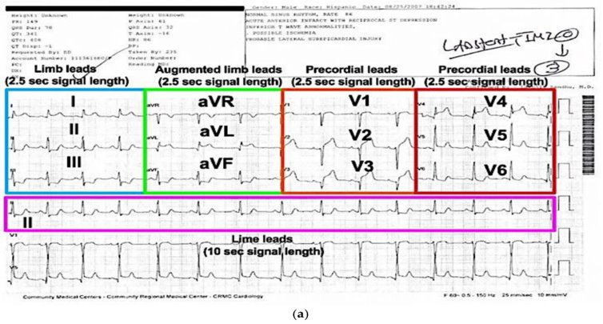

**Fig 7. A Sample Recorded Electrocardiogram, Source: ECGlibrary.com**

**2.5.1 Morphology of the intervals of Normal ECG**

When we analyze an ECG wave, we can see that it is composed of discrete segments. ECG waves and intervals are classified as P-wave, PR interval, P.R. segment, Q.R.S. Complex, J-wave, ST segment, T-wave, and U-wave. Traditionally, ECG interpretation begins with the P-wave. The P wave is indicative of atrial depolarization (activation). P.R. interval is the time period between the P-wave onset and the Q.R.S. complex onset. The PR interval is used to assess the normality of impulse conduction from the atria to the ventricles. At the end of the P-wave and the commencement of the Q.R.S. complex, the P.R. Segment is a flat line. Additionally, it indicates the atrioventricular node's sluggish impulse conduction. The PR segment acts as the ECG curve's baseline (referred to as the reference line). The amplitude of any deflection/wave is determined by comparing it to the P.R. section. The Q.R.S. complex represents the ventricles depolarizing (activating). It is always referred to as the "Q.R.S. complex," even if all three waves are not always present. The Q.R.S. complex is a reflection of left ventricular depolarization because the electrical vector generated by the left ventricle is many times bigger than the electrical vector generated by the right ventricle. The ST-Segment corresponds to the action potential's plateau phase (phase 2). The S.T. segment must always be examined because it is altered under a variety of settings. Numerous situations result in fairly distinctive ST-segment alterations. The S.T. segment is particularly relevant in acute myocardial ischemia because ischemia results in ST-segment deviation. The magnitude of depression/elevation is expressed as the height difference between the J point and the P.R. segment. The J point denotes the commencement of the S.T. segment. The T-wave indicates contractile cells' rapid repolarization (phase 3), and T-wave alterations occur under a wide variety of situations. U-wave is a positive wave that occurs immediately following the T-wave. Its amplitude is typically one-fourth that of the T-wave. Figure 8 illustrates the shape of various segments of an ECG wave.

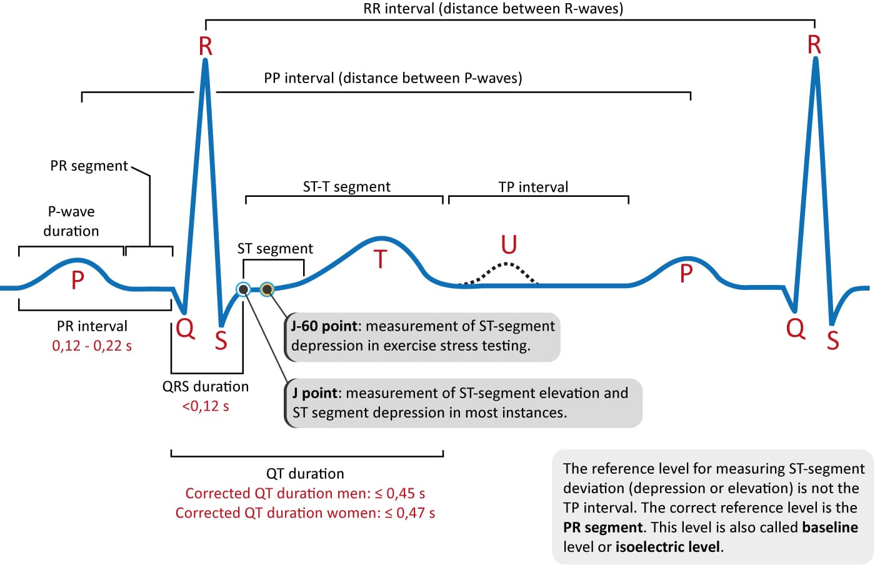

**Fig 8. Morphology of an ECG wave, Source: researchgate.net**

**2.6 Convolution Neural Network (CNN)**

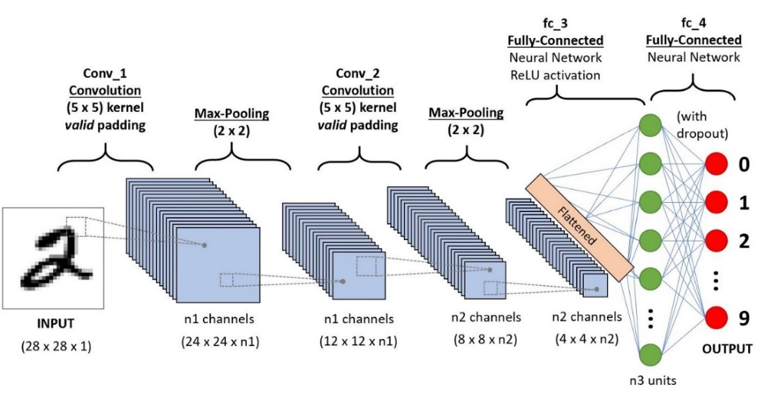Convolutional Neural Networks have made substantial progress in a range of fields connected to pattern identification during the last decade, ranging from image processing to speech recognition. The most significant advantage of CNNs is the reduction in the number of parameters required by ANNs. With this success, researchers and developers are rethinking the use of conventional ANNs in order to execute complex tasks that were previously beyond their capabilities. An essential principle is that CNN problems should not be spatially dependent in any way whatsoever. All that counts is that the objects are spotted, no matter where they appear in the images. Abstract characteristics are another important aspect of CNN. In picture classification, for example, the edge may be identified first, followed by simpler shapes in the second layer, and lastly by higher-level attributes in the subsequent layers. Figure 9 shows how CNN works.

**Fig 9. Sample Convolution Neural Network, Source:** **towardsdatascience.com**

**3. LITERATURE REVIEW**

**3.1 Steps to Perform ECG**

An ECG can be performed in a variety of methods. The test is generally performed by attaching a series of small, adhesive sensors called electrodes to your arms, legs, and chest. These are attached to an ECG recording machine via wires. These are the steps necessary to record an individual's ECG using the traditional approach. Figure 10 and figure 11 shows position of ECG electrodes. The following are the processes involved in recording an ECG of a person using the traditional method:

* To perform an ECG with 12 leads, electrodes are placed over the body.
* Despite the name 12 Lead ECG, it only uses ten electrodes. Certain electrodes are connected in pairs, providing two leads.
* Electrodes are typically self-adhesive pads filled with a conducting gel. The electrodes are attached through snap-on connectors to the electrocardiograph or heart monitor's cables.
* ECG Gel enhances conductivity between the skin and the electrodes of the heart rate monitor.
* The ECG's twelve leads reflect twelve electrical images of the heart from twelve different angles. The standard 12-lead method comprises the placement of 10 electrodes on the body: one on each leg and six across the chest.
* The six limb leads, which are acquired from three electrodes attached to the right arm, left arm, and left leg, stare vertically at the heart.
* The earth electrode is located on the right leg.
* The ECG machine uses the negative pole as a zero reference, while the positive pole serves as the "point of view" and the line linking the two poles serves as the "line of sight." 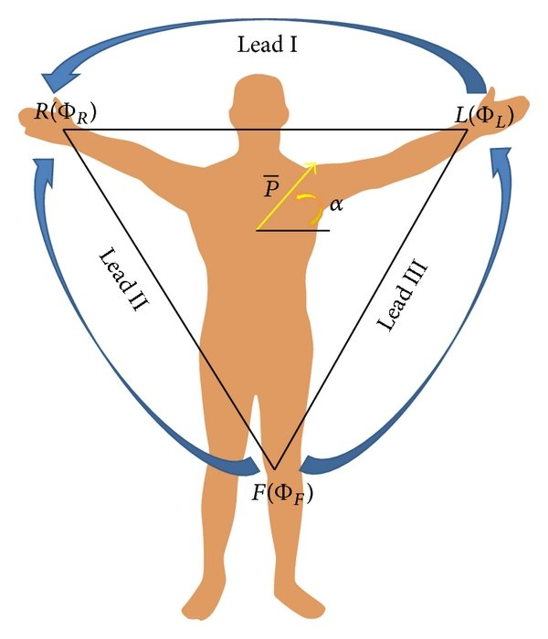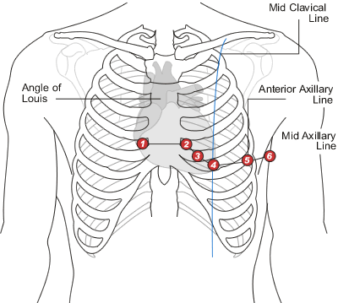

**Fig 10. Limb Leads Fig 11. Chest Leads**

**Source: litfl.com**

* 1. **Working Principle of ECG**

It is based on the principle that when a muscle contracts, a little electric current is generated that may be detected and measured using electrodes positioned appropriately on the body. A resting electrocardiogram requires the subject to lie in the resting position, with electrodes put on the arms, legs, and six locations on the chest above the heart area. The electrodes are adhered to the subject's skin using a specific lubricant. The electrode detects and transmits the current to an amplifier located inside the electrocardiograph. The electrocardiograph then intensifies the current and records it as a wavy line on paper. A sensitive lever records variations in current on a moving sheet of paper in an electrocardiograph. Additionally, a modern electrocardiograph can be connected to an oscilloscope, a device that displays current on a screen. If the Φ symbol is used to denote potentials at different regions, then, On completing the circuit by touching the Left and Right thumbs or arms, we can get Lead I; similarly, using Foot and Right-arm, we can get Lead II and so on.

* 1. **Case Studies**
     1. **Apple's Single Lead ECG Watch**

Apple ECG watches (figure 12) require approximately 30 seconds of wait time before providing ECG at any moment. The ECG graph and anticipated findings are displayed on an ECG application running on an Apple iPhone. It can only record single-lead ECGs since touching the left and right arms complete a circuit that produces results for Lead I; unless we touch the left arm and the foot, or the right arm and the chest, or some other potential combinations, we cannot obtain any other ECG signal than Lead I. Only sinus rhythm (or normal rhythm, i.e., consistent 50-100 BPM) and atrial fibrillation can be detected using a single-lead ECG Apple released two versions, each with improved prediction and hardware capabilities. It can track A.F. up to 50-120 BPM in version 1 and up to 50-150 BPM in version 2. Additionally, it is capable of detecting low or high heart rates. Apple claims about 98% accuracy of Atrial Fibrillation detection.

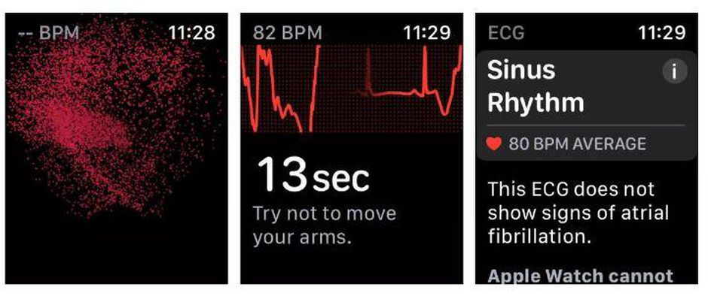

**Fig 12. Apple ECG Watch, Source: Support.apple.com**

* + 1. **Sanket's 12 Lead ECG and Circuit Diagram**

Sanket's 12 Lead (figure 13) ECG is an Indian firm Sanket's ECG recording device that has been widely used in rural markets with the assistance of physician's teams to record ECGs in an easier and less expensive manner without the need for additional electrode implantation. This is a little gadget that may be placed on various regions of the body sequentially to capture the person's ECG. It's a little complicated, and it's probably only possible to perform an ECG with the assistance of a qualified someone who understands which two points on the body correspond to which ECG leads. This is a versatile item that may be utilized anywhere and at any time. If the device is misplaced, there may be complications with the reading of the ECG, which can also result in inaccuracies. It has a total of 2 electrode systems, which are touched at different body parts using electrodes to get a single lead ECG; completing different circuits, we can get all 12 Leads ECG using it; below is the figure of Sanket's 12 Lead portal ECG and the circuit diagram of the device.

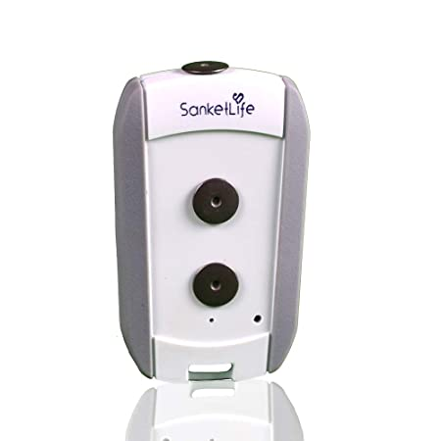

**Fig 13. Sanket's 12 lead ECG, Source:** **mashelkarfoundation.org**

* 1. **Electrode & Micro Pattern Electrodes**

Electrical systems perceive (measure) or stimulate (induce) electrical potentials within cells passively or actively and serve as a link between biological structures and electronic systems. Our bodies generate ionic potentials, which must be converted to electronic potentials before they can be detected. Electrodes are devices that convert ionic potential to electrical potential. The Bio Electrode is the transducer that converts the ionic body current to the electronic current flowing through the electrode. It conducts even a very small amount of current across the interface between the body and the electronic measuring circuit. When the current flows from the electrode to the electrolyte, oxidation is predominant; when the current flows in the opposite direction, the reduction is dominant. The electrodes are constructed of an Ag/AgCl disc encased in conductive gel and have a resistance of around 100 m. The diameter of the disc is approximately 25 mm, the diameter of the gel is approximately 16 mm, and the diameter of the Ag/AgCl disc is around 10 mm. A cross-sectional scan reveals that the gel beneath the tip is approximately 600 m thick but is significantly thicker in the remaining portion, making it impossible to calculate the electrode equivalent area. The gel enhances conductivity between the skin and the electrodes of the heart rate monitor. ​For Microelectrodes, detection of the physical stress at different parts of body, the polymer substrate is made of PDMS and the conducting material to coat the micro/nanopillars includes Aluminum or RGO. the computing processor process the voltage signal correlates it with the physical stress by receiving the voltage signal from the sensor arrangement corresponding to the body-potential comes out of a particular muscle of the body part; comparing the voltage signal's amplitude and frequency with respect to a reference value to detect physical stress of the body part whereby higher amplitude and frequency of the signal corresponds to a stressed condition of the muscle compared to relaxed situation; converting the voltage to a digital signal and transfers it with the detected physical stress wirelessly to the remote recipient including cooperative mobile application embodied in user's mobile phone for real-time display of the detected physical stress and the digital signal and/or storing data associated with the same for future analysis. Figure 15 shows micro pattern electrodes and figure 16 shows gel electrodes, some electrodes that can be used are “Electrically conductive Silicone Rubber Sheet” or “Conductive Hook & Loop” which have resistivity of around 1.57 to 1.4Ω/in2.

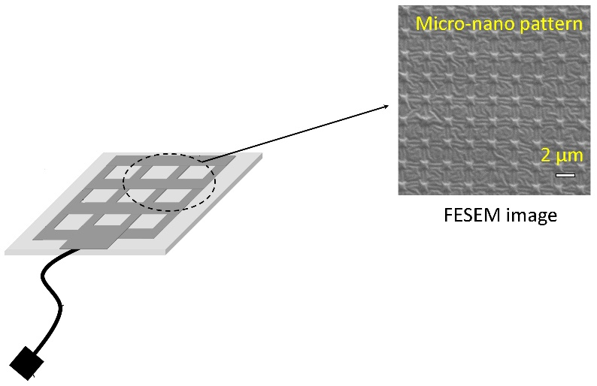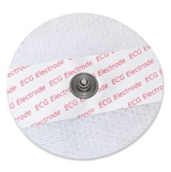

**Fig 14. Micro-Pattern Electrodes Fig 15. Sticky Gel Electrodes**

**Source: Sciencedirect.com**

* 1. **Sample Dataset**

We extracted apart from the sample ECG dataset "AliveCor's Short Single Lead ECG Recording" that is publicly available online. This dataset provides a collection of ECG amplitudes at various time scales, each representing one ECG wave, with the final column labeled as Normal and Abnormal ECGs, the latter of which includes Atrial Fibrillation. A single row looks to be an image matrix in ECG datasets, and we also know that any two categorized ECG waveforms are nearly the same; for example, one Normal ECG wave will be nearly identical to another Normal ECG wave, and one A.F. wave will be nearly identical to another A.F. wave. This is how our sample dataset appears, with the label Normal ECG and Abnormal ECG, Amplitude data ranging from -1mV to 1mV, and Time in seconds. We have a total of 2000 milliseconds in our dataset or 33.33 seconds. The dataset contains a total of 2001 columns and 8530 rows; the following Table 1 contains a sample of the dataset.

|  |  |  |  |  |  |  |  |  |
| --- | --- | --- | --- | --- | --- | --- | --- | --- |
| 0 | 1 | 2 | 3 | 4 | 5 | 6 … | 1999 | Label |
| 0.035032 | 0.037155 | 0.044586 | 0.063694 | 0.076433 | 0.085987 | 0.089172 | -0.02229 | Normal |
| -0.03529 | -0.03257 | -0.03094 | -0.02986 | -0.03149 | -0.0342 | -0.03746 | 0.001086 | Normal |
| -0.30392 | -0.26144 | -0.22222 | -0.19281 | -0.17647 | -0.1634 | -0.14706 | -0.06536 | Normal |
| 0.109467 | 0.117604 | 0.128698 | 0.142012 | 0.153107 | 0.161982 | 0.170118 | 0.013314 | Abnormal |
| -0.01986 | -0.01715 | -0.01444 | -0.01173 | -0.00993 | -0.00812 | -0.00632 | 0 | Abnormal |
| 0.051136 | 0.0625 | 0.090909 | 0.142045 | 0.238636 | 0.335227 | 0.4375 | 0.119318 | Normal |
| -0.12387 | -0.12991 | -0.13595 | -0.14804 | -0.16012 | -0.17221 | -0.18429 | 0.253776 | Normal |
| -0.04615 | -0.0441 | -0.04205 | -0.03897 | -0.0359 | -0.03179 | -0.02769 | 0.019487 | Abnormal |
| -0.02503 | -0.02503 | -0.02253 | -0.01877 | -0.01126 | 0.001252 | 0.017522 | -0.0776 | Abnormal |
| -0.07178 | -0.07015 | -0.06852 | -0.06688 | -0.06362 | -0.06199 | -0.05873 | 0.014682 | Normal |
| -0.94677 | -0.95057 | -0.95437 | -0.95817 | -0.96198 | -0.96578 | -0.96578 | 0.235741 | Normal |
| 0.056582 | 0.047344 | 0.038106 | 0.025404 | 0.013857 | 0.004619 | 0 | 0.023095 | Normal |
| -0.08696 | -0.08152 | -0.05978 | -0.02174 | 0.021739 | 0.086957 | 0.173913 | -0.1413 | Abnormal |
| -0.06887 | -0.13642 | -0.24636 | -0.39735 | -0.5894 | -0.81192 | -1.04503 | -0.08212 | Normal |
| -0.09927 | -0.1102 | -0.12022 | -0.12659 | -0.13206 | -0.13752 | -0.14117 | -0.03005 | Abnormal |
| -0.44531 | -0.5 | -0.55078 | -0.58984 | -0.65625 | -0.73438 | -0.76172 | -0.33984 | Normal |
| -0.39799 | -0.4214 | -0.44816 | -0.47492 | -0.50836 | -0.54181 | -0.57525 | -0.03344 | Abnormal |
| 0.027211 | 0.017007 | 0.006803 | 0 | 0 | -0.0068 | -0.0068 | 0.530612 | Normal |
| 0.632735 | 0.720559 | 0.716567 | 0.612774 | 0.327345 | -0.06986 | -0.48503 | 0.011976 | Normal |
| 0.04501 | 0.052838 | 0.086106 | 0.172211 | 0.297456 | 0.455969 | 0.632094 | -0.00196 | Abnormal |
| 0.008351 | 0.039666 | 0.058455 | 0.075157 | 0.087683 | 0.100209 | 0.110647 | 0.096033 | Normal |
| 0.036072 | 0.024048 | 0.026052 | 0.048096 | 0.06012 | 0.036072 | 0.008016 | -0.08216 | Abnormal |
| -0.02728 | -0.03104 | -0.03481 | -0.03763 | -0.04045 | -0.04327 | -0.04516 | 0.015052 | Abnormal |
| 0.264368 | 0.266667 | 0.268966 | 0.268966 | 0.268966 | 0.267816 | 0.265517 | -0.0092 | Abnormal |
| 0 | -0.00084 | -0.00084 | -0.00168 | -0.00336 | -0.00419 | -0.00587 | -0.0302 | Normal |
| 0.086763 | 0.094549 | 0.101224 | 0.106785 | 0.113459 | 0.119021 | 0.124583 | -0.02558 | Normal |
| -0.1519 | -0.15506 | -0.15823 | -0.16139 | -0.16139 | -0.16456 | -0.16456 | 0.003165 | Abnormal |

**Table 1. Alivecor's Single Lead ECG dataset**

# **4. METHODOLOGY**

**4.1 Objective**

Our first purpose was to acquire information about the ECG and its operation, to examine the entire product offerings on the market, and to analyze what issues remain and how we may come up with a better solution, some modification, or enhancement. By analyzing the limitations and constraints of Apple's ECG watch and Sanket's 12 Lead ECG, we were able to develop a portable, non-invasive point-of-care system for detecting/monitoring stress levels in various body parts of the human subject, which could be adapted to facilitate early detection of a variety of diseases or disorders related to the heart that can be correlated with an increase in stress in various body parts of the subject. Now, we can collect our own datasets and do analyses on them via the smartphone. Additionally, the data analytics section includes a forecast of whether a subject has Atrial Fibrillation or not.

**4.2 Block Diagram**

Below, figure (Figure 20) shows the block diagram that can be implemented on a circuit box. It should contain a total of three units, namely a Battery Unit (Power Source), a Sensing Unit, and a Wireless Communication Unit. The sensing Unit should capture leads, monitor heart rate, and process them like passing waves via various electrical circuits like amplifier or bandpass filters and denoising the final output signal. Then Analog signals are converted to digital signals and sent to Wireless Unit. Output data generated from the sensing unit should be transferred to mobile application using the wireless may be wifi/Bluetooth/internet cloud channels.

The electrical output from the heart is represented by the input analogue signal, which has a voltage range of 0 mV to 3 mV and a frequency range of 0.01 Hz to 250 Hz. The output signal will contain serialised digital data translated from analogue signals. The procedure can be carried out on an ECG equipment; operations like as filtering, amplification, and digitising can be carried out and delivered to a PC or smartphone device. Further processing can be done to identify and anticipate different wave signals, such as QRS detection, which requires a bandwidth of 0.5Hz to 40Hz, and arrhythmia detection, which requires a bandwidth of 0.05Hz to 60Hz.

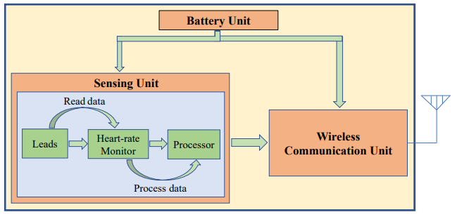

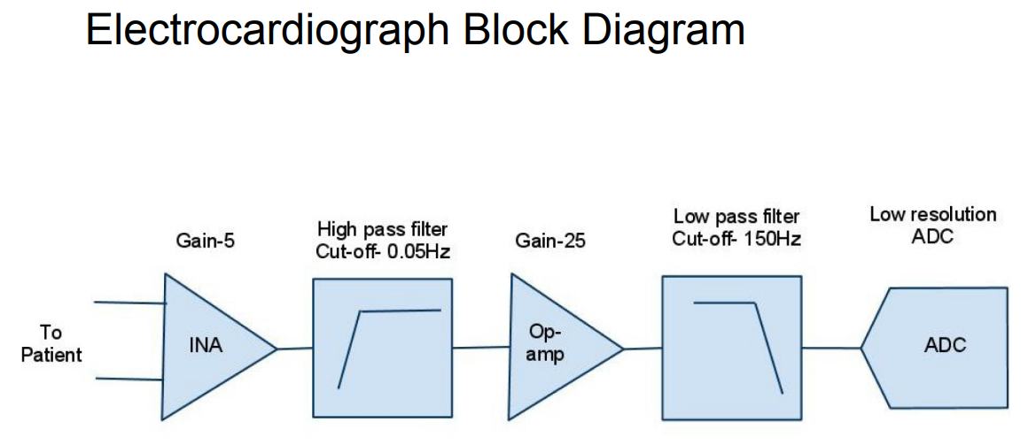

**Fig 17 Block Diagram of an ECG device**

**Source: Mobile-based Tele-ECG for rural health care**

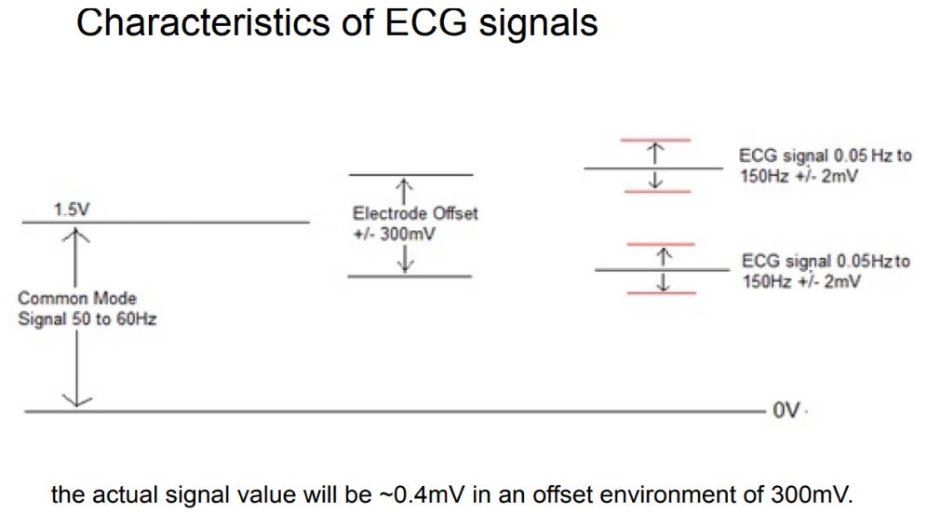Output Analog Voltage ECG signals can differ from one person to the next. The front end of an ECG must be capable of handling extremely low signals ranging from 0.5 mV to 5.0 mV. The signal has a direct current component of up to 300 mV from the electrode-skin contact and a common-mode component of up to 1.5 V from the potential difference between the electrodes and the ground. The usable bandwidth of an ECG signal varies according on the application, ranging from 0.5 Hz to 50 Hz for critical care unit monitoring to 1 kHz for late-potential assessments (pacemaker detection). A typical clinical ECG application has a bandwidth ranging from 0.05 Hz to 100 Hz.

**Figure 20 Working Principle of Circuit**

**4.3 Sources of Noise**

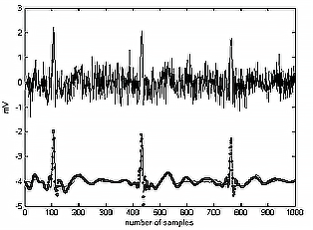Patient breathing causes baseline drift (low-frequency AC signal noise). Interference with power lines ( 50-60Hz noise from power lines). Muscle noise (This noise is extremely difficult to eliminate because it is in the same frequency range as the genuine signal.) Usually, it is remedied in software.) Other interfering factors (i.e., radio frequency noise from other equipment). We utilize instrumentation amplifiers with very strong common-mode rejection ratios on the order of 100dB to remove common mode noise. The patient body is then driven with an inverted common-mode signal, and the noise is removed using software methods after the acquisition.

**Figure 21 ECG Noise; Source: elentra.healthsci.queensu.ca**

**4.4 Circuit Diagram & Components**

# Below figure shows the circuit diagram of the portable non-invasive ECG device that contains two electrodes, a bypass capacitor circuit to remove D.C. noise, an amplifier circuit to amplify lower signal detection, a bandpass filter circuit to get a ranging signal and a notch filter to remove the noise and tune it

# .

**Fig 22. Single lead 2 Electrode ECG Circuit Diagram, Source:** **courses.cs.washington.edu**

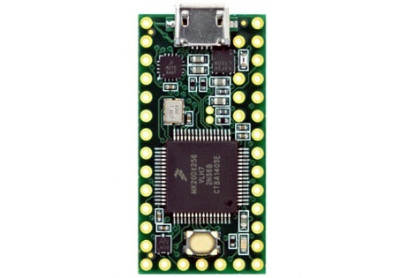These are the major components that are required to build the setup:

* **Teensy 3.2**
  + USB-based programmable microcontroller chip
  + Higher R.O.M. (64K) and Flash (256K)
  + 16 general purpose D.M.A. channels
  + 34 digital input/output pins, 12 P.W.M. output pins
  + The output voltage of 3.3V and 5V

**Figure 23 Teensy3.2** [**Source**](https://www.pjrc.com/store/teensy32.html)

* 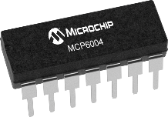**MCP6004 Low power Op-Amp**
  + It's a Quad Op-amp (14-Pin) package.
  + Rail-to-rail input and output over the 1.8 to 6V operating range.
  + Gain–bandwidth product (GBWP) of 1 MHz with current only 100 µA.
  + 14-lead PDIP, 3.3V as the power source

**Figure 24 MCP6004** [**Source**](https://www.microchip.com/en-us/product/MCP6004)

* 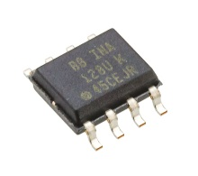**INA128U Amplifier**
  + Amplifies the low voltage signal.
  + Low-power amplifier offering excellent accuracy.
  + The versatile 3-op amp (8pins) design and small.

**Figure 25 INA128U** [**Source**](https://www.ti.com/product/INA128#:~:text=The%20INA128%20and%20INA129%20are,kHz%20at%20G%20%3D%20100).)

* **Adafruit BluefruitLE**
  + 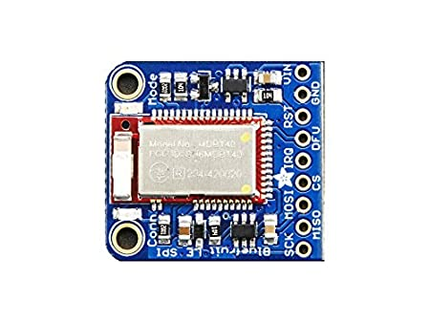Easy to add Bluetooth Low Energy connectivity
  + ARM Cortex M0 core running at 16MHz
  + 256KB flash memory
  + 32KB SRAM
  + 5V-safe inputs (Arduino Uno friendly, etc.)
  + On-board 3.3V voltage regulation

**Figure 26 BlueFruit** [**Source**](https://www.adafruit.com/product/2479)

* 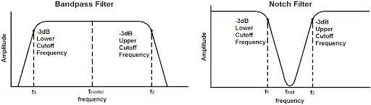**Band-Pass Filter**
  + Allows frequencies within a certain range
  + Here range used is 1Hz to 40Hz signals are allowed

**Figure 27 Band-Pass Filter** [**Source**](https://www.washington.edu/students/crscat/cse.html)

* **Notch filter** 
  + Band-Stop filter attenuates frequencies within a range

while passing other frequencies unaltered.

* + Range of frequencies is very narrow.
  + Range of frequencies that are attenuated is stopband

**Figure 28 Notch Filter** [**Source**](https://www.washington.edu/students/crscat/cse.html)

* **Bypass Capacitor** 
  + It shorts A.C. signals to the ground so that any A.C. noise that may be present on a D.C. signal is removed, producing a cleaner D.C. signal.
  + The value of the bypass capacitor should be at least 1/10th of the resistance across the emitter resistance, RE at the lowest frequency intended to be bypassed.

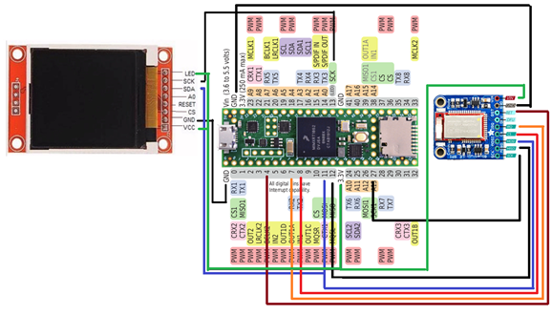 The analog output of the circuit is connected to an analog pin in teensy. The below figure shows how to connect the LCD and Adafruit Bluefruit LE with Teensy 3.2.

**Fig 29 Circuit Diagram Connecting Teensy**

**4.5 Datapoints**

We may visualize the image matrix data points by plotting each row from the sample ECG dataset "AliveCor's Short Single Lead ECG Recording." We are charting Amplitude on the y-axis and Time on the x-axis, where Amplitude is between -1mV and 1mV and Time is between 0 and 2000 seconds. The following figure 17 demonstrates how a single-row plot appears.

**Fig 30. Sample ECG Wave Plot from the dataset**

**4.6 Redefining Dataset**

There were no missing data points discovered when studying the dataset. To begin, we processed the label column and changed the data points from string to Boolean values of 0 and 1, where 0 denotes a normal electrocardiogram and 1 indicates atrial fibrillation. Now, to determine the skewness and bias of the data, we generated histograms of labeled columns to get insight into the data; the below histogram plot illustrates the column's occurrence of 0 and 1. In figure 18, we can see from the data points that around 58% of the data had Normal ECGs, and the remainder contained Abnormal ECGs suggesting Atrial Fibrillation. Following that, we shuffled the dataset and divided it into several pieces for training, validation, and testing.

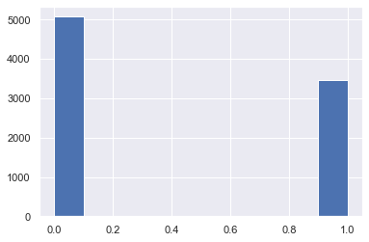

**Fig 31. Histogram count of 0 (Normal), 1 (Abnormal) Occurrence**

**4.7 Dataset Modelling and Architecture**

After getting the insights into the data, we can see there is no correlation between any two columns, and every column has its own importance, so our features are the time values at which we are recording ECG with equal weights given to each column and labeled column as out predicting column. In comparison with each row as an image matrix, it seemed to be an image classification problem, now, to predict the image we chose to build a Convolution Neural Network model (shown in figure 19) as this works better in a sharp object and edge detections techniques.

Convolutional Neural Networks (CNNs) are made up of neurons that self-optimize and learn. Each neuron will continue to accept input and perform an operation (such as a scalar product followed by a non-linear function) - the fundamental building block of an infinite number of artificial neural networks. From the input raw image vectors through the final output class score, the entire network will continue to reflect a single perceptual scoring function (the weight). The last layer will contain loss functions associated with the classes, and all of the established methodologies for traditional ANNs will remain applicable. The neurons that compose the layers of the CNN are structured in three dimensions: the input's spatial dimension (height and width) and the depth. The depth parameter does not refer to the overall number of layers in the ANN. When the activation function "ReLU" (Rectified Linear Unit) is employed, the neurons within each layer will link to only a small part of the layer preceding it.

Each ECG image is represented by a one-dimensional matrix. We divided the dataset 80% as training and 20% as a validation set. We chose a kernel size of 5; kernel size refers to the length of the one-dimensional convolution window; and our filter size ranges from 32 to 512, where filter size denotes the output space's dimensionality as we need to check different parts of the image searching for data points. We started with a model consisting of approximately nine Convolution Neural Network layers and then performed maximum pooling, dropouts, and lastly, the development of dense layers. Maximum pooling is used here to refer to a pooling process that determines the maximum or largest value in each patch of a feature map. The resulting feature maps are down-sampled or pooled to highlight the most abundant feature in the patch rather than the feature's average presence in the patch in the case of average pooling. We made use of dropouts. It is a strategy in which randomly chosen neurons are ignored during random training. This means that their contribution to the activation of downstream neurons is removed temporally during the forward trip, and any weight modifications to the neuron are skipped during the backward pass.

As a neural network learns, neuron weights get embedded in the network's surroundings. Neuronal weights are set for specific characteristics, resulting in some specialization. Neighboring neurons develop an increased reliance on this specialization, which, if carried too far, might result in a model that is excessively specialized to the training data. Complex co-adaptations allude to a neuron's reliance on the context during training. One may envision that if neurons are randomly dropped from the network during training, another neuron will be required to step in and manage the representation required to make predictions for the missing neurons. This is believed to result in the network learning numerous independent internal representations. Afterward, we utilized Adam Optimizer to make a stochastic gradient descent with a learning rate alpha of roughly 0.00006, with a total of 100 epochs and a batch size of approximately 128. Low learning rates may take a very long time to converge, whereas high learning rates may not even come close to the convergence point at all if they are used. On the basis of loss, accuracy, and precision, we evaluated our model using python libraries of TensorFlow, Keras, and Scikit-Learn.

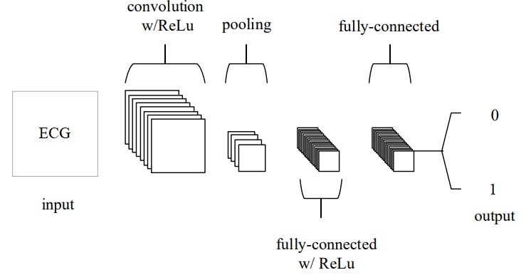

**Fig 32. Convolution Neural Network**

# **RESULTS AND DISCUSSIONS**

To better represent normal and abnormal ECGs, we renamed the designated column 0 and 1, respectively, after determining that the data set was not skewed. In the end, we built a deep learning convolution neural network model using this data set. We assessed the model over the dataset after fitting and assessing our final model. We were able to get an 81.36 % accuracy. We constructed the confusion matrix and estimated the precision, recall, and F1 score after analyzing the model that was trained and tested over 100 validation epochs and 128 batch sizes. To simplify binary classification, the x-axis displays true or false classifications with expected classifications on the other side of the matrix, while the y-axis displays the predicted classifications, as shown in figure 20 and figure 21.

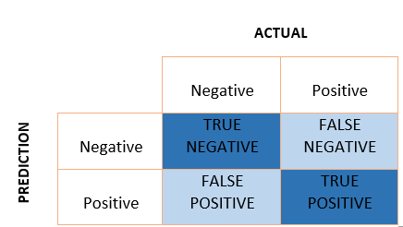

**Fig 20. A Sample Confusion Matrix**

* **True Positive** is when the model accurately predicts the positive class, i.e., when both the forecast and the observed value are positive; from the confusion matrix, we got a total of True Positive as 225.
* **True Negatives** occur when the model accurately predicts the negative class (i.e., the forecast and the observed value are both negatives); we got a total of 469 as True Negative.
* **False Positive** occurs when the model predicts the negative class incorrectly, i.e., predicted-positive for actual-negative, we got a total of 128 False Positive values.
* **False Negative** occurs when the model predicts the positive class incorrectly; that is, predicted-negative for actual-positive; we got a total of 31 False Negative values.

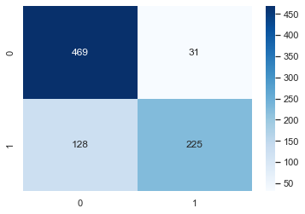

**Fig 32. Confusion Matrix**

Precision and recall are both critical for knowledge retrieval, with positive classes being more important than negative classes. Precision is defined as the percentage of truly positive predictions out of all positive predictions. Precision is a value between 0 and 1.

Recall is the percentage of expected positives in relation to the total positive. We want to ensure that we do not miss any fraudulent transactions. As a result, we wish to keep False-Negative as low as possible. In these instances, we can make a trade-off between precision and recall. Similarly, we do not want to overlook any patient in the medical application. As a result, we place a premium on recall.

The F1 score is calculated as harmonic mean of precision and recall. It accounts for both false positives and negatives. As a result, it performs admirably on an unbalanced dataset. All three are shown in table number 2.

|  |  |  |  |
| --- | --- | --- | --- |
|  | **Precision** | **Recall** | **F1 score** |
| **Normal** | **0.79** | **0.94** | **0.86** |
| **Atrial Fibrillation** | **0.88** | **0.64** | **0.74** |

**Table 2. Precision, Recall, and F1 score Table**

On running a total of 100 epochs over the Convolution Neural Network (CNN), the below shows the plot of the variation of loss at different epochs, here orange line denotes validation loss and blue line denotes training loss. For validation loss it converges about 28% as shown in figure 22 and figure 23.

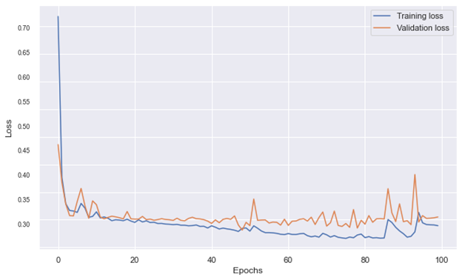

**Fig 33. Loss v/s Epochs for Training Loss and Validation Loss**

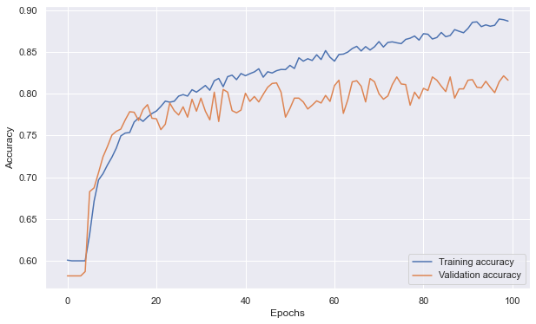

**Fig 34. Accuracy v/s Epochs for Training Accuracy and Validation Accuracy**

# **CONCLUSIONS**

Throughout this article, we've endeavored to provide a thorough overview of the procedures that must be followed when taking an ECG. The many components of the presentation were introduced, as well as the connection that existed between them. The equations and operating principles of an ECG are discussed in detail. We can draw a few conclusions from the research we've done thus far.

1. We learned how our hearts operate and how an electrocardiogram works, as well as which risk factors may be detected using an electrocardiogram. We also learned about the different types of heart disease.
2. We learned about the products that are now available on the market, as well as the need to make a move from traditional to portable devices in order to stay competitive.
3. Specifically, we looked at how a convolutional neural network can be built and how it can be used to effectively predict whether or not a person has Atrial Fibrillation with an accuracy of 81.36% and validation loss was 28%.
4. We learned how to measure the precision and recall of our model.
5. We looked into micropattern electrodes, which be used to improve the accuracy, grip, and precision of the setup in the future.
6. We learned how to assemble a complete circuit and make a product, and we developed a non-invasive portable ECG recording device.
7. Dataset were recorded and plotted and simultaneously tested on a machine learning model to detect whether the ECG detected was Normal or not.

Following that, we can proceed to improve device configuration, implementation, and data collection. Eventually, we can get a marketable and portable, non-invasive point-of-care ECG device that will record electrocardiograms and other vital signs. More work can be done on the machine learning model to make it more efficient and can be trained on the bigger dataset. This setup can be assembled into a small portable ECG device like Sanket's ECG Device. This device can detect the abnormalities in the ECG using our convolution neural network model.

# **REFERENCES**

1. [Design of ECG Homecare:12-lead ECG acquisition using single channel ECG device developed on AD8232 analog front end | IEEE Conference Publication | IEEE Xplore](https://ieeexplore.ieee.org/document/7352529)
2. [(16) (PDF) Accessing the ECG Data of the Apple Watch and Accomplishing Interoperability Through FHIR (researchgate.net)](https://www.researchgate.net/publication/351923381_Accessing_the_ECG_Data_of_the_Apple_Watch_and_Accomplishing_Interoperability_Through_FHIR)
3. [Take an ECG with the ECG app on Apple Watch - Apple Support (IN)](https://support.apple.com/en-in/HT208955)
4. [CSE 466 Lab 7: Analog Front End for an Electrocardiograph (washington.edu)](https://courses.cs.washington.edu/courses/cse466/13au/labs/l7/l7.html)
5. <https://courses.cs.washington.edu/courses/cse466/07wi/lectures/02-microcontrollers.pdf>
6. [(16) (PDF) True Unipolar ECG Machine for Wilson Central Terminal Measurements (researchgate.net)](https://www.researchgate.net/publication/282434777_True_Unipolar_ECG_Machine_for_Wilson_Central_Terminal_Measurements)
7. [A Novel Wearable Device for Continuous Ambulatory ECG Recording: Proof of Concept and Assessment of Signal Quality (nih.gov)](https://www.ncbi.nlm.nih.gov/pmc/articles/PMC6468449/)
8. [Electronics | Free Full-Text | Advances of ECG Sensors from Hardware, Software and Format Interoperability Perspectives (mdpi.com)](https://www.mdpi.com/2079-9292/10/2/105)
9. [Comparison of Baseline Wander Removal Techniques considering the Preservation of ST Changes in the Ischemic ECG: A Simulation Study (hindawi.com)](https://www.hindawi.com/journals/cmmm/2017/9295029/)
10. [Passive Detection of Atrial Fibrillation Using a Commercially Available Smartwatch | Atrial Fibrillation | JAMA Cardiology | JAMA Network](https://jamanetwork.com/journals/jamacardiology/fullarticle/2675364)
11. [AF classification from a short single lead ECG recording: The PhysioNet/computing in cardiology challenge 2017 | IEEE Conference Publication | IEEE Xplore](https://ieeexplore.ieee.org/document/8331486)
12. [Performance Metrics: Confusion matrix, Precision, Recall, and F1 Score | by Vaibhav Jayaswal | Towards Data Science](https://towardsdatascience.com/performance-metrics-confusion-matrix-precision-recall-and-f1-score-a8fe076a2262)
13. [(16) (PDF) An Introduction to Convolutional Neural Networks (researchgate.net)](https://www.researchgate.net/publication/285164623_An_Introduction_to_Convolutional_Neural_Networks)
14. [A Hybrid Textile Electrode for Electrocardiogram (ECG) Measurement and Motion Tracking - PubMed (nih.gov)](https://pubmed.ncbi.nlm.nih.gov/30279370/)
15. [Electrically Conductive Silicone Rubber Sheet, Thickness: 1.6 to 3.2 mm, Rs 125 /meter | ID: 16623200873 (indiamart.com)](https://www.indiamart.com/proddetail/electrically-conductive-silicone-rubber-sheet-16623200873.html)